**Model Calibration**

* **Hydrologic modeling**

Model Structure:

Si

P

Ei

Su

Cr

S

Pe

Ss

Qus

Sf

Qs

Qiu

Quf

Qf

Qt

Ea

With this single lumped model, we have 8 parameters which are *Imax*, *Ce*, *Sumax*, *beta*, *Pmax*, *Kf*, *Ks*, *Tlag*. In the beginning, we initialize these parameters with 2, 0.5, 100, 2, 0.01, 5, 0.05, 0.001 respectively, which we have done in our second assignment and results are shown below.

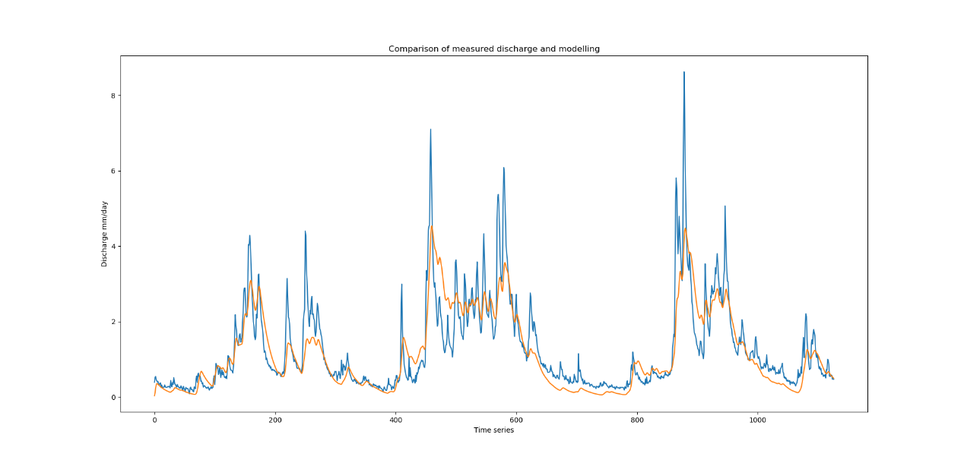

Fig.1 Discharge output without calibration

* **Model calibration**

In this week, we concentrate on model calibration with Monte-Carlo simulation method and our objective function is called Nash and Sutcliffe coefficient (NS) which coincident with high flow pattern and the logarithm of NS represents the low flow.

Monte-Carlo simulation is a way that randomly reproduces parameters which are shown above. In this case, we confine the range of parameters with the maximum and minimum limitation. Then, iteratively generate 5000 times random sets inside the limitations.

1. NS determined calibration

The objective function is given below and we know it should give a better performance in the high flow pattern.



Run through the model in Python and plot calibrated discharge output and parameter distribution through iteration.

We find out that the optimal NS coefficient is 0.886 and the correlation coefficient is 0.942.

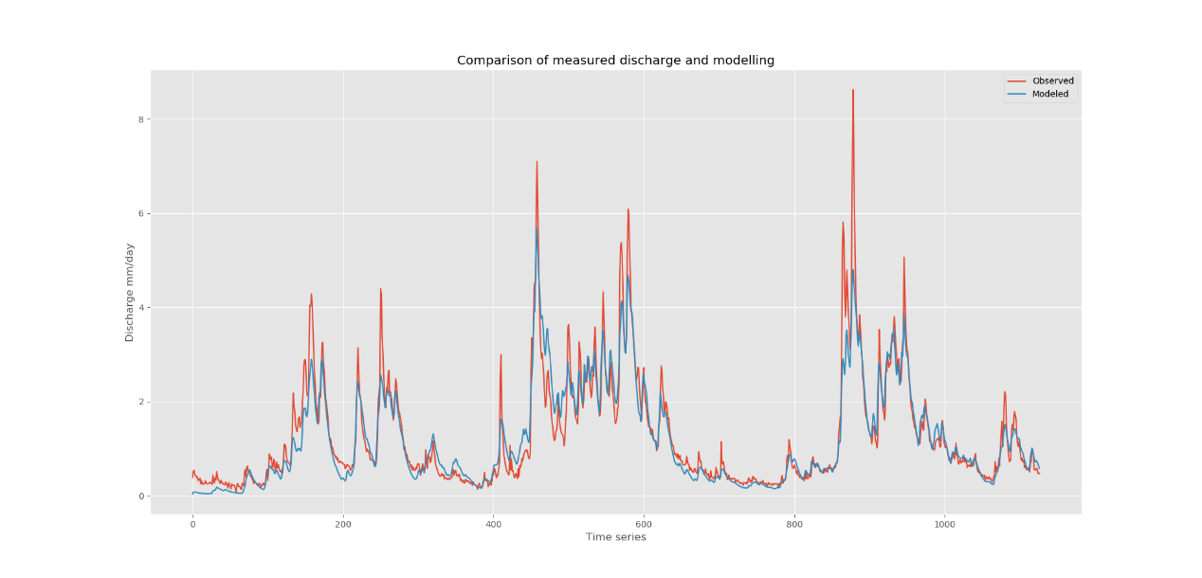

Fig.2 Discharge output with calibration (NS)

Comparing to the former initialized parameter, the performance of the calibrated model improves a bit.

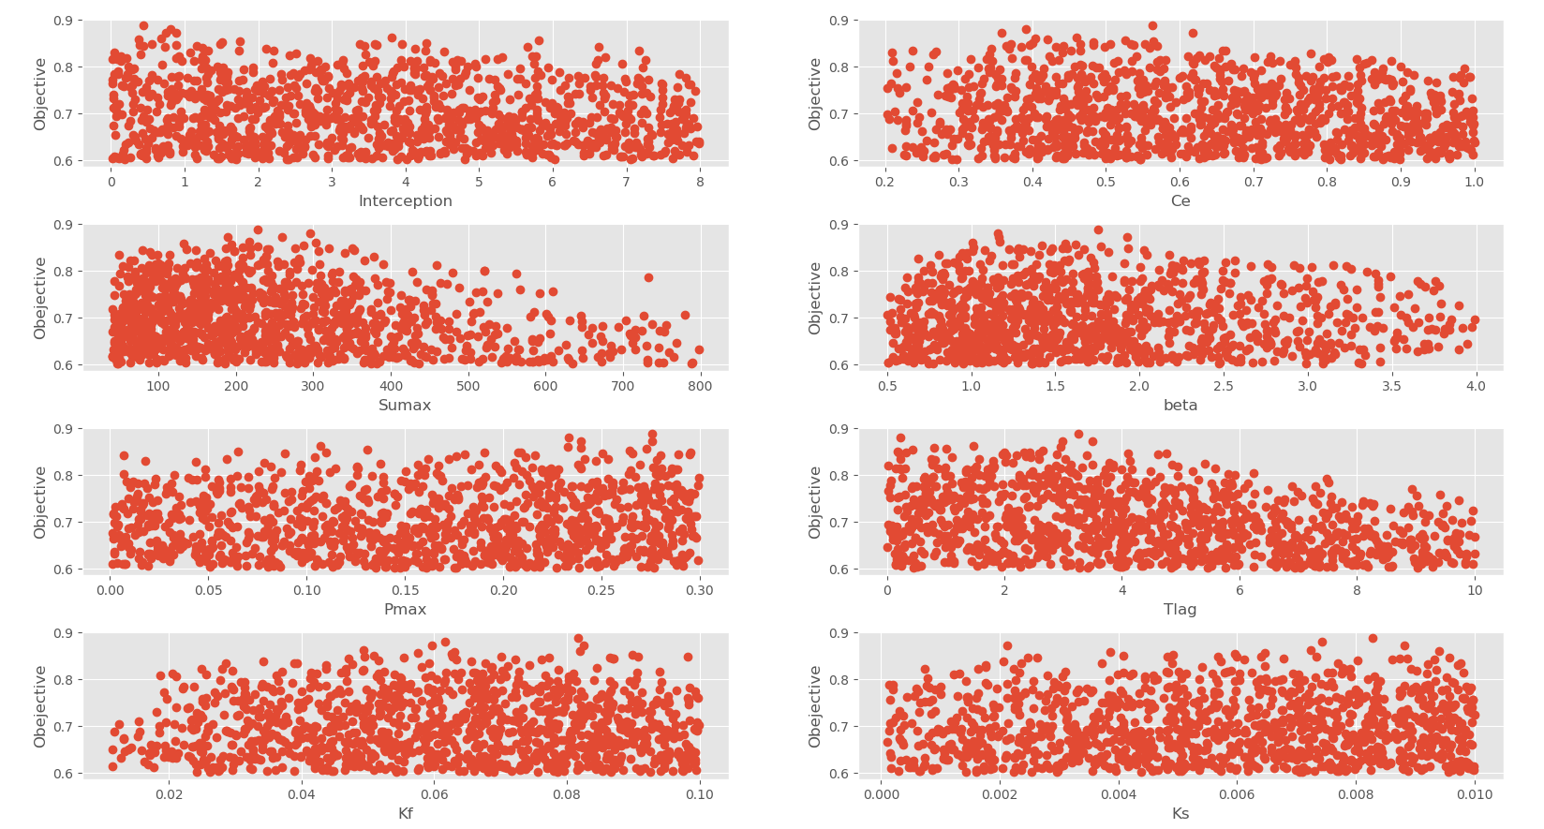

Fig.3 Parameters distribution due to iteration (NS)

Through the graph above, we can analyze the uncertainties of these independent parameters but for better visualization, a box plot is made below.

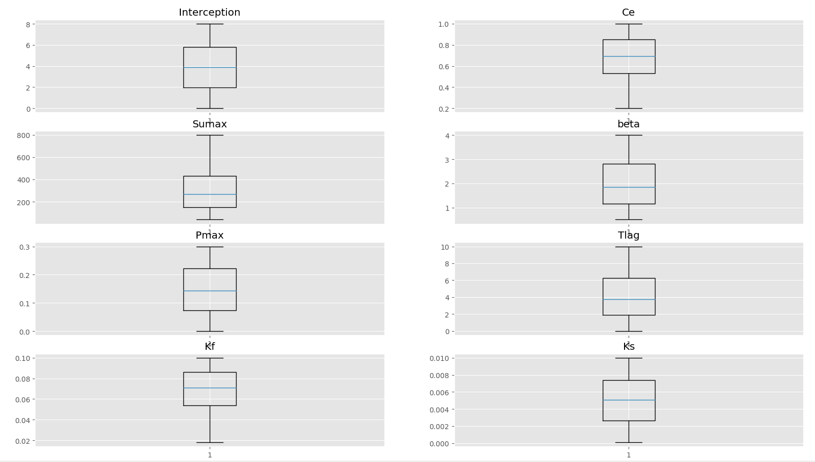

Fig.4 Box plot of calibrated parameters (NS)

This shows us the first and third interquartile range which is the upper and lower bound, median value and outliers.

1. Logarithm NS determined

The log of the flows give little discrepancies with comparing to the normal one. The log of NS coefficient is 0.887 and correlation coefficient is 0.935 which is slightly smaller than before.

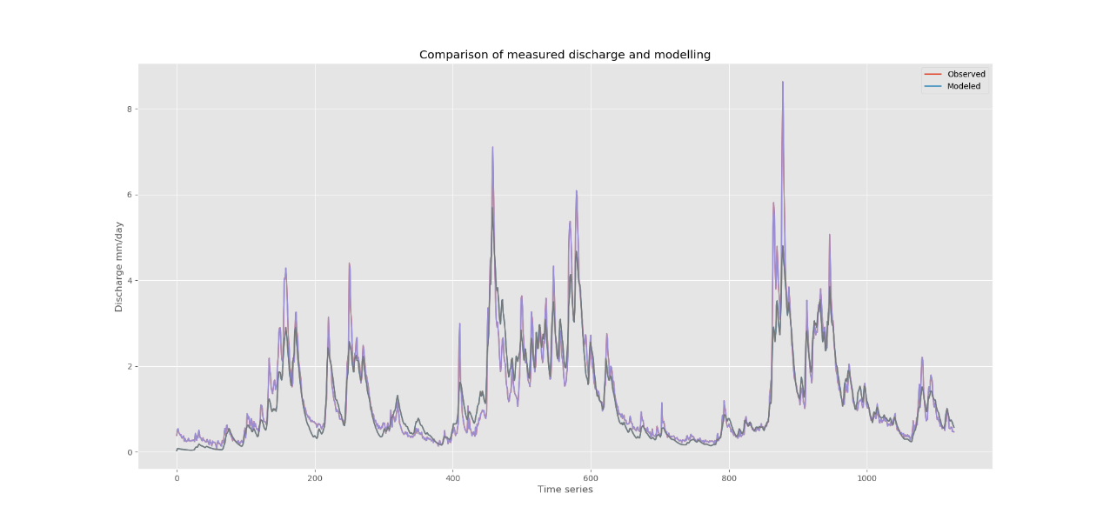

Fig.5 Discharge output with calibration (log-NS)

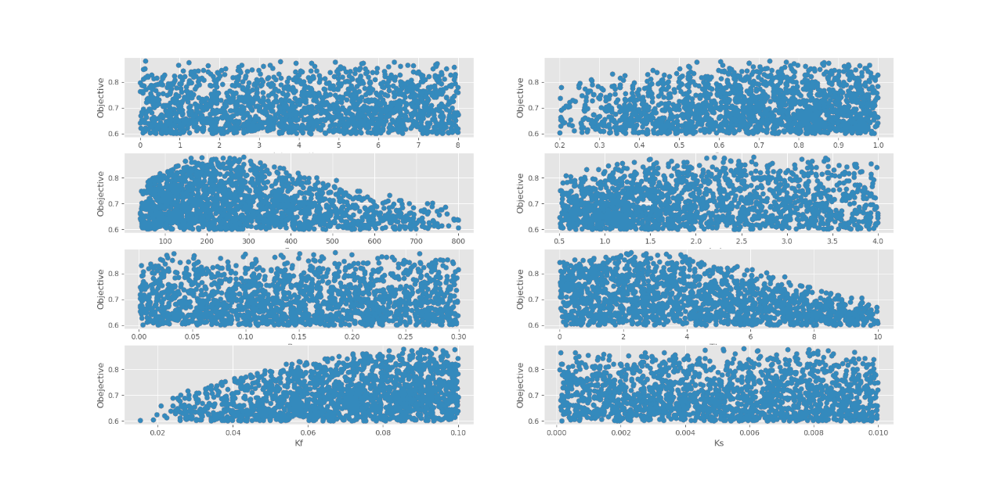

Fig.6 Parameters distribution due to iteration (log-NS)

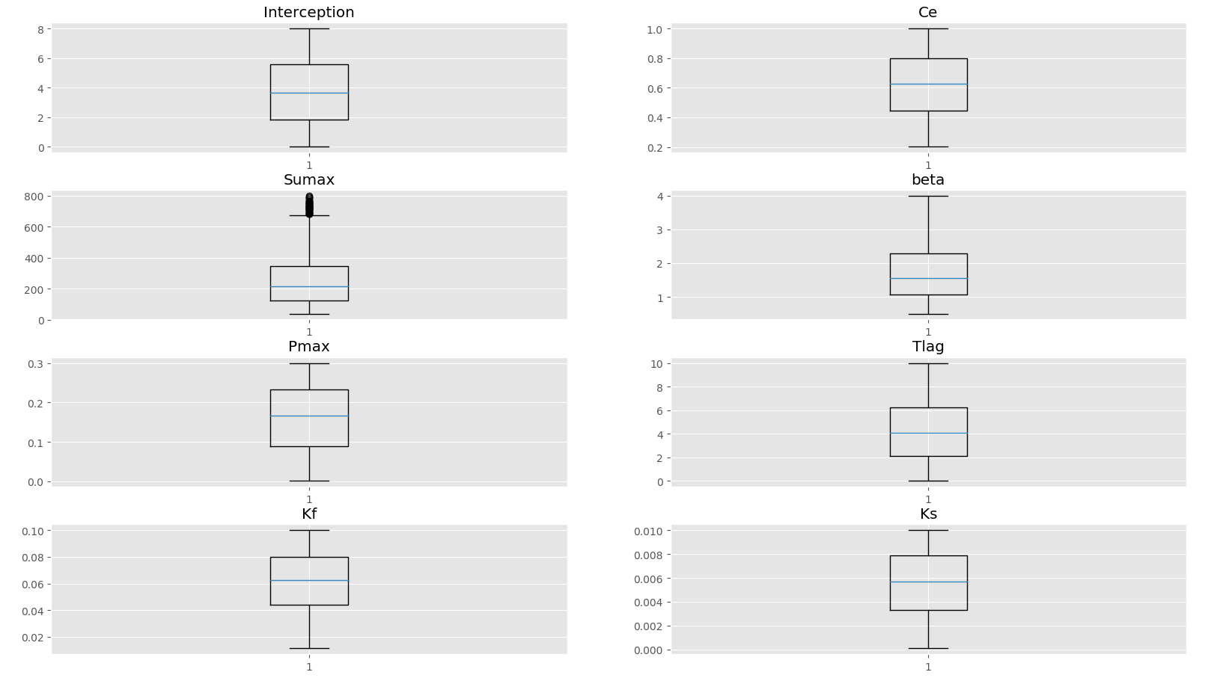

Fig.7 Box plot of calibrated parameters (log-NS)